TASK1 Zombie:-
#include <stdlib.h>
#include <stdio.h>
#include <sys/types.h>
#include <unistd.h>
int main()
{
pid_t fk = fork();
// Parent process
if (fk > 0)
{
sleep(15);
printf("Name : Sharez\n");
printf("Id : BECE-0004\n");
}
// Child process
else
{
exit(0);
}
return 0;
}
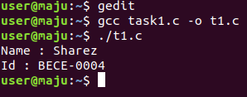

TASK2 Orphan:-

#include<stdio.h>
#include <sys/types.h>
#include <unistd.h>
int main()
{

int p = fork();

if (p > 0)
printf("in parent process");

else if (p == 0)
{
sleep(20);
printf("in child process");
}

return 0;
}

